**Microcalcification Detection in Digital Mammograms based on Wavelet Analysis and Neural Networks**

* J.S.Leena Jasmine ,** Dr.A.Govardhan, *** Dr.S.Baskaran

**Abstract**

Early detection of primary tumor is an essential and effective method to reduce mortality. This paper presents a new approach for detecting microcalcification in digital mammograms **employing the combination of wavelet analysis of the image by applying artificial neural networks (ANN) for building the classifiers**. **The microcalcification corresponds to high frequency components and the detection of microcalcification is achieved by extracting the macrocalcification features from the wavelet analysis of the image and we use these results as an input of neural network for classification.** The neural network contains one input, two hidden and one output .The system **is classified normal from abnormal, mass for microcalcification and abnormal severity(benign or malignant).**The experiments demonstrate that our approach can provide true detection rate approximately 87% and 0 false detection per image which is significant. The evaluation of the system is carried on **Mammography Image analysis Society (MIAS) dataset.**

**INTRODUCTION**

The main goal of this paper is to devise a better CAD technique for classification of abnormality in digital mammograms are designed and evaluated. First **features are extracted from the wavelet analysis of the image, which represents the unit of classification.**In the classification stage we use back propagation neural network. The porpose of the system is to determine abnormal severity in the abnormal one.In this paper the abnormal cases: mass(circumscribed mass and speculated mass) and microcalcifiaction are considered.

**MATERIALS AND METHODS**

Microcalcifications **are relatively high-frequency components buried in the background of low frequency components and very high noise in the mammogram.** So we can first extracts the region of interest from the image using coordinates (x,y) and radius value already provided by radiologist in **the MIAS database**. Then use the neural network classifier based on feature extracted from the wavelet analysis of the image. It consist of preprocessing, **feature extraction and classification stages**. **Histogram equalization and gray level thresholding techniques are applied for enhancing the images.** Features are extracted from the whole image which represents the unit for classification. We called this technique mammography classifier based on globally processed image. The purpose of this system is **to classify normal mammogram from abnormal one and to determine abnormal severity in the abnormal one. It could be mass (benign or malign) or microcalcification (benign or malign).** In this paper the abnormal cases: mass (circumscribed and speculated and microcalcification)and microcalcifications are considered. The neural network contains one input, two hiddenand one output layers. Layers have 20, 40, 25, and 1 neurons respectively. A neural network is a set of connected input/output units where each connection has a weight associated with it. During the learning phase, **the network learns by adjusting the weights so as to be able to predict the correct class of the input samples. The back propagation technique performs the classification of features into benign or malignant.**

**Discrete 2-D Wavelet Transform**

For images, there exist an algorithm similar to the **one dimensional case for two-dimensional wavelets and**

**scaling functions obtained from one- dimensional ones by tonsorial product.** This kind of two-dimensional DWT leads to a decomposition of approximation coefficients at level j in four components: the approximation

at level j + 1, and the details in three orientations (horizontal, vertical, and diagonal).

The following chart describes the basic decomposition steps for images:



**3.2 Mass features**

Benign and malignant are differentiated through mass attributes of margin density and location Round, low density masses with smooth sharply defined margins are considered benign. High density, speculated masses with poorly defined margins are considered malignant.

**3.3 Microcalcification features**

The attributes of size, shape, density, distribution pattern, and number of microcalcification are examined when differentiating between benign and malignant micro calcifications.Benign and malignant microcalcifications can occur with or without a mass. Benign microcalcifications are typically large (1-4mm diameter), coarse, round or oval, and uniform in size and shape. **Their distribution pattern is typically scattered or diffuse. If the microcalcifications are clustered, their number is less than 5 per cluster. Malignant microcalcifications are typically microscopic and fine, liner branching, stellate-shaped, and varying in size and shape. Their distribution pattern is grouped or clustered, and they are innumerable.**

**3.4 Data sources**

The data collection that was in our experiments was taken from the Mammographic Image Analysis Society (**MIAS**) [19].This same collection has been used in other 3 studies of automatic mammography classification. It consists of 322 images, which belong to three categories: **normal, benign and malign**, which are considered abnormal. In addition, the abnormal cases are further divided into six categories**: circumscribed masses, speculated** **masses, microcalcifications, ill-defined masses, architectural distortion and asymmertry.** All images are digitized at a resolution of 1024 * 1024 pixels and ejght-bit accuracy (gray level). They also include the location of any abnormality (like the center of a circle surrounding the tumor),its radius, breast position (left or right), type of breast tissues (fatty, fatty glandular abd dense) and tumor type if exists( benign or malign)

**THE PROPOSED SYSTEM**

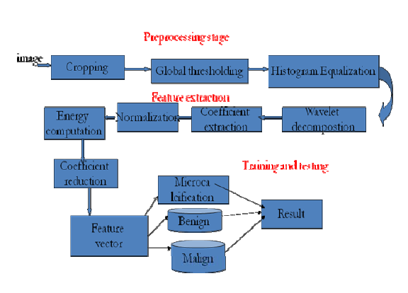

**4.1 IMAGE ENHANCEMENT STAGE**

Enhancement methods based on wavelet transform proved to be very useful because of their multi-resolution properties .**Wavelet transform is a robust tool for filtering that represents images heiarchically on the basis of scale and resolution,analyzing high-spatial frequency phenomenoa localized in space, and, thus can effectively extract information derived from localized high-frequency signals, such as those emitted by microcalcification**. This section introduces the preprocessing technique before the feature extraction stage. The preprocessing stage involves two main phases, which are used together. **The first phase involves the removal of background information and unwanted parts from the image, while the second phase deals with enhancing the contrast of region of interest in the image. In a typical mammogram several different areas are present such as the**

**image background, microcalcification and noise appear at different scales and so they can be selectively enhanced, detected or reduced within different resolution levels.**

**4.1.1 Image pruning**

In the MIAS dataset [19], we had images that were very large (has size 1024 X1024) and almost 50% of the whole image comprised of the background with a lot of noise. In this phase, we applied a cropping operation to the image to prune the images with the help of the crop operation in Image processing. Cropping cuts off the unwanted portions of the image. Thus, almost all background information and most of the noise is eliminated. An example of cropping that eliminates the label on the image and the black background. The size of the cropped images is (600 x 600).

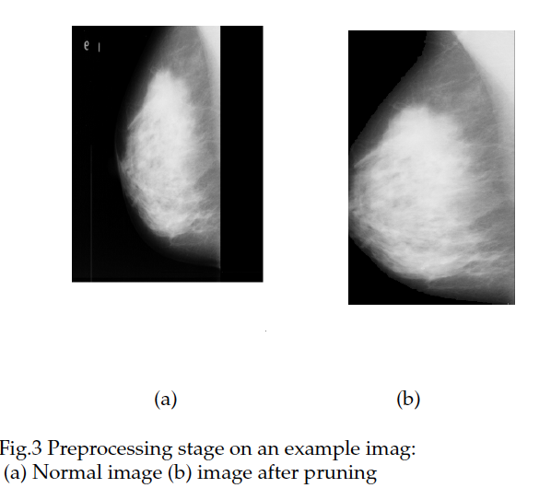

**4.1.2 Global gray level thresholding**

In this stage upper (260) and lower threshold (140) were selected .The pixels between a pre-selected upperthreshold and lower-thresholding of the gray level histogram is retained and all others are set zero. To apply this technique upper and lower thresholds are determined according to be sure that the region of interest pixels values are between these thresholds. It returns the color values of specified image pixels.

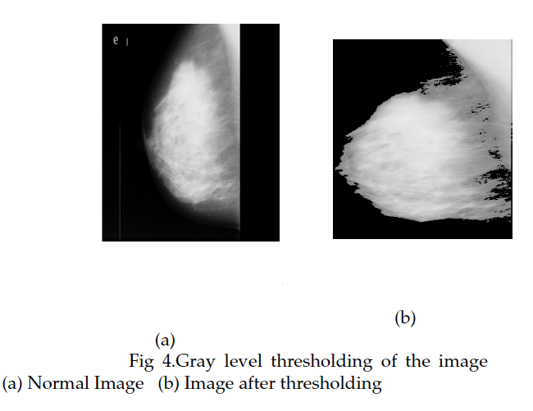

**4.1.3 Histogram equalization**

First, the image is RGB image is converted to the gray scale form. Then the image is subjected to the histogram

equalization.Histogram equalization improves the quality of the image. In histogram equalization, the goal is to map the input image to the output image so that gray values in the output image are uniformaly distributed. For most practical images, gray values need to be redistributerd. In histogram equalization we tried to spread gray values uniformly over the full gray- scale range. It increases the contrast range in an image by increasing the dynamic range of gray levels.

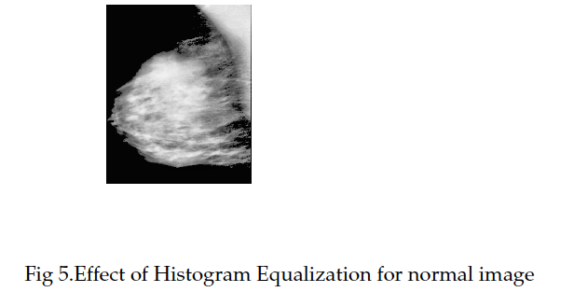

**4.2 FEATURE EXTRACTION STAGE**

Features are extracted from the enhanced images based on the wavelet decomposition process. These features are

passed to the classification stage. There are five processing steps in the features extraction stage. Features, in our system, are extracted from the coefficients that were produced by the wavelet analysis decomposition.

**4.2.1 Wavelet decomposition**

wavelet transforms or wavelet analysis is propably the most recent solution to overcome the shortcomings of the Forier transform. A wavelet is a waveform of effectively limited duration that has an average value of zeroIn the first step, coefficient vector are extracted from wavelet decomposition of the image. The decomposition operations return the wavelet decomposition of the image at predefined scale, using the wavelet name, as Daubechies. Outputs are the decomposition vector C and the corresponding bookkeeping matrix S. The decomposition vector consists from three detail coefficients vector, horizontal detail coefficients, vertical detail coefficients and diagonal detail coefficients, and one approximation are row vectors. In this paper the Daubechies wavelet is used. The maximum useful wavelet decomposition scale (N) that the image decomposed at this scale. It helps to avoid unreasonable maximum scale values. The maximum scale decomposition of image is determined according to number of scales that contain irredundant information. In this paper, we had images that were of size (600 X600).

**4.2.2 Coefficients Extraction**

In this step, we extracted horizontal, diagonal and vertical details coefficients from the wavelet decomposition

structure (C, S). It returns the horizontal H, vertical V and diagonal D detail coefficients vectors at scale N. These vectors are extracted at each scale without scale one. We ignore scale 1 coefficients because it contains high frequency details and noise. These details are insignificant information that will not affect the classification accuracy and image quality. We compute the image quality after zeroing coefficients in scale one and it was 97% of the original image.

**4.2.3 Normalization**

In the third step, the coefficients vector (H, V and D) for scale two to five are normalized after extracted .The normalization process is achieved by dividing each vector by its maximum value. The results of this operation is that all vectors values become less than or equal one. The normalization is used to similipy the coefficient value.

**4.2.4 Energy computation**

We compute the energy for each vector by squaring every element in the vector. The produced values are considered as features for the classification process.

**4.2.5 Feature reduction**

Benign and malignant masses are differentiated through mass attributes of margin, density and location. Round, low density masses with smooth sharply defined margins are considered benign. High density, speculated masses with poorly defined margins are considered malignant. Since the image has a large size, it produces high numberof coefficients. Therefore, to reduce the number of features by summing a predefined number of energy values together.

4.3 CLASSIFICATION STAGE

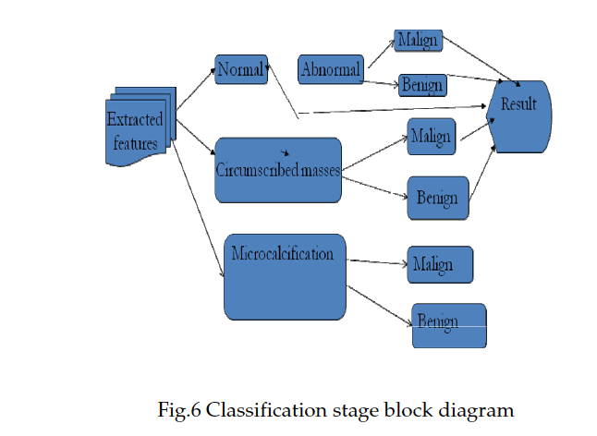

In order to specify the features that will be used as inputs to the classification system, to classify mammograms into normal and abnormal categories. The mammogram is considered abnormal if it contains tumor (mass or microcalcification) . if the result for evaluating the tested mammogram is abnormal; it is entered to next classification stage to determine if it contains mass or microcalcification tumor. Finally abnormal mammogram is classified into malignant or benignin the third stage. The result of classifier is computed by evaluating the tested mammogram features and then computing theminimum error between the tested one and the output results to the classifier.

**5 EXPERIMENTAL RESULTS**

In this section, compare the result with the exiting method Rafayah Mousa [21]. More than 800 coefficients per feature were tested. Table 1 shows the result of trained and tested results.Features are from levels (2–6) and various combinations of these levels are examined in all simulations.. The average success rate is computed, in each experiment, by dividing the number of right classified images at the number of all tested images. Each classifier is trained at different number of steps.

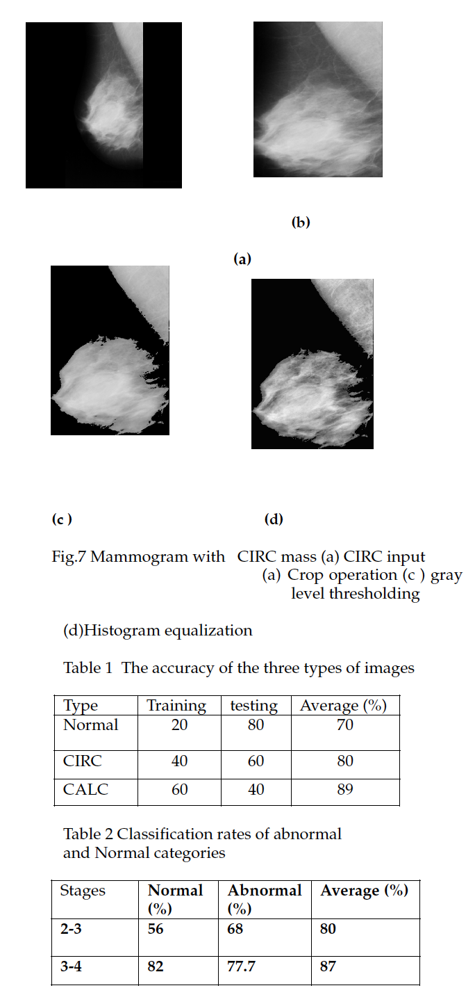

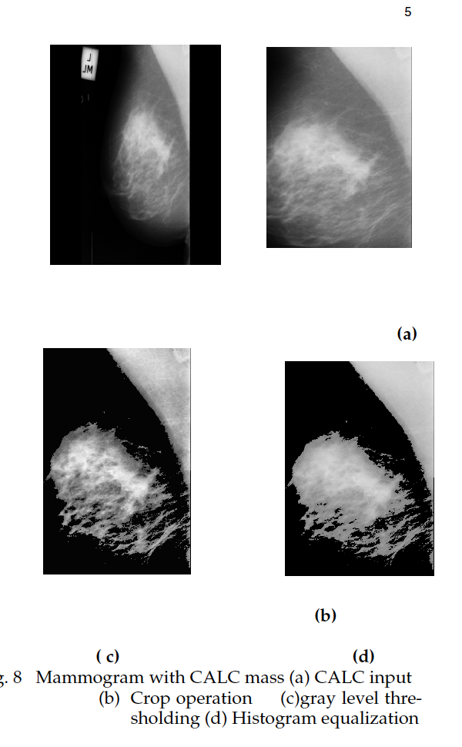

**CONCLUSION**

We have presented wavelet transform for image enhancement, feature extraction and Neural network for classification process.. This method is very effective for automatic detection and classification. We have examined and compared with several features for each technique. The experiments show that our system can achieve a detection rate of about 87% and 0 false detection per image for fatty-glandular mammograms.The evaluation of the system was carried out on MIAS dataset. Mammography is one of the best methods achieve the best performance with features extracted from levels 3–4 because masses have larger sizes and more clear, and it is represented by low frequency information which embodied in the lowest levels by wavelet decomposition. of abnormalities in digital mammogram.